1.6. Patron Card Creator
Get there: Home › Tools › Patron card creator
The Patron Card Creator allows you to use layouts and templates which you design to print your custom patron cards on your standard printer. Multiple virgin card labels are assumed to be arranged in a grid on a sheet. Here are some of the features of the Patron Card Creator module:
- Customize patron card layouts with text retrieved from the koha patron data
- Design custom card templates to match the label sheets
- Build and manage batches of patron cards to print
Export single or multiple batches
Export single or multiple patron cards from within a batch
where export means that a .pdf is created with your patron cards ready for viewing, download and printing
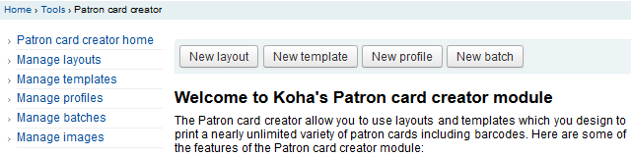
At the top of each screen within the Patron Card Creator, you will see a toolbar allowing quick access to relevant functions. The menu to the left of each screen also allows easy access to the different sections of the Patron Card Creator. Above the left side menu you find the bread crumb trail, a specific indication as to where you are and also allows quick navigation to previously traversed sections. Finally you can find more detailed information on each section of the Patron Card Creator by clicking the online help link at the upper right-hand corner of every page.

1.6.1. Layouts
- Get there: Home › Tools › Patron card creator › Manage card Layouts
A layout defines the information to be printed onto each card. Up to three lines of text, the patron's number in barcode representation and up to two images can be printed on to the card.

Add a Layout
To add a new layout click on the 'New layout' button at the top of your page which brings you to the Edit form immediately. You may also choose to press 'Manage layout' on the left side. Here you are offered a list of available layouts you can select for editing. But in the top of the page there is still the 'New layout' button.

- The name you assign to the layout is for your benefit, name it something that will be easy to identify at a later date
- The Units pull down is used to define what measurement scale you're going to be using for your layout.

A Postscript Point is 1/72" an Adoba Agate is 1/64", an Inch is 25.4 SI Millimeters
- Next note if this layout is for the front or the back of the patron card. As of 3.18.5 this is a relict of functionallity that is removed. If you want labels for both sides of your patron cards you have to define two layouts and print a batch for each side.
- You have the option of adding up to 3 lines of text to your card. Your text can be static text of your choosing and/or fields from the patron record. If you want to print fields from the patron record you want to put the field names in brackets like so - <firstname> <surname> For more fields look up database schema table borrowers in Home › Reports.
- For each line of text, you can choose your font, font size and the location of the text on the card using the lower X and Y coordinates
- In order to show the barcode and the patron card number you will need to check the 'Print Card Number as Barcode' option. If you want the number to print in human readable format you will need to check the 'Print Card Number as Text Under Barcode' option.
- Finally you can choose up to two images to print on the card.
  - One can be the patron image which you can resize to meet your needs.
  - The other image can be something like a library logo or symbol that you uploaded using the 'Manage Images' module of the Patron Card Creator Tool.
- It is the designers responsibility to define textlines, barcode and images such that overlap is avoided.
After saving, your layouts will appear on the 'Manage Layouts' page.

1.6.2. Templates
Get there:Home › Tools › Patron card creator › Manage card Templates
A template describes the arrangement of labels on the label sheet/card stock you are using. This might be Avery 5160 for address labels, Gaylord 47-284 for spine labels or Avery 28371 for your patron cards, just to give a couple of examples. All of the information you will need for setting up a template may be printed on the packaging, and if not it can usually be found on the vendor's website or can be measured from a sample sheet.

Add a Template
To add a new template click on the 'New template' button at the top of your page which brings you to the Edit template form immediately. You may also choose to press 'Manage templates' on the left side. Here you are offered a list of available templates you can select for editing. But in the top of the page there is still the 'New template' button.

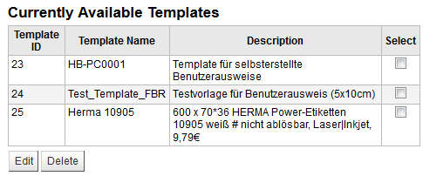
Using the form that appears after pressing either 'Edit' or 'New template'you can define the template for your sheet of labels or cards.

- Template ID is simply a system generated unique id
- Template Code should be the name of this template to identify it on a list of templates
- You can use the Template Description to add more information about the template
- The Units pull down is used to define what measurement scale you're going to be using for the template. a Postscript Point is 1/72" an Adoba Agate is 1/64",
an Inch is 25.4 SI Millimeters

- A profile is a set of "adjustments" applied to a given template just prior to printing which compensates for anomalies unique and peculiar to a given printer .Do not specify a profile unless needed, i.e. do not click to define a printer profile. It is not possible to remove a profile from a template but you can switch to another profile and such resort to a profile with zero values for all corrections.
If you know that your printer needs some adjustment you should now define a profile or do so later by editing the template The values in the profile can be corrected any time too.
  - Before defining a profile try printing some sample cards so that you can take measurements to define a profile that does the right adjustments for your printer/template combination.
  - If you are using different printers you may be required to define several templates that are identical only different profiles are specified.
After saving, your templates will appear on the 'Manage Templates' page.

1.6.3. Profiles
Get there:Home › Tools › Patron card creator › Manage card Profiles
A profile is a set of "adjustments" applied to a given template just prior to printing which compensates for anomalies unique and peculiar to a given printer . This means if you set a template up and then print a sample set of data and find that the items are not all aligned the same on each card in the grid, you need to set up a profile for each printer or even different tray selections on the same printer to make up for the differences in printing styles, such as the shifting of text to the left, right, top or bottom.
If your cards are printing just the way you want, you will not need a profile.

Add a Profile
To add a new profile, you want to click on the 'New Profile' button at the top of your page. Using the form that appears you can define the values to correct the card misalignments on your label sheet. You may also choose to press 'Manage profiles' on the left side and select one of the currently available profiles for editing.

The Printer Name and Paper Bin are just reminders for what context you have set the profile.
- Template will be filled in once you have chosen which template to apply the profile to on the template edit form
- The Units pull down is used to define what measurement scale you're going to be using for your profile.

- Offset should be used when the entire image is off center either vertically or horizontally
  - Creep describes a condition where the distance between the labels changes across the page or up and down the page
Example: the text is printed 0.25" from the left edge of the first label, 0.28" from the left edge of the second label and 0.31" from the left edge of the third label. This means the horizontal creep should be set to (minus) -0.03" to make up for this difference.
  - For offset and creep values, negative numbers move the printed information up and to the left on the printed sheet and positive numbers move down and to the right
After saving, your profiles will appear on the 'Manage Profiles' page.

Once you have saved your new profile, you can return to the list of templates and choose to edit the template that this profile is for.

1.6.4. Batches
- Get there: Home › Tools › Patron card creator › Manage card Batches
A batch is a collection of patrons for whom you want to generate cards.

Add a Batch
To add a new batch, you want to click on the 'New Batches' button at the top of your page. Choosing the menu item 'Manage batches' on the left a list of already defined batches is displayed. In this display you can either select a batch for editing or add a new batch.
For a new batch a message pops up and directs you to select patrons to be processed in this batch.
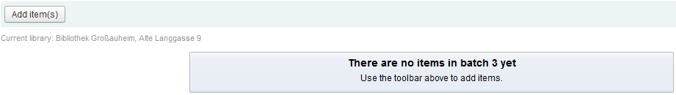
After pressing the Add item(s) butten the Patron Search window pops up.
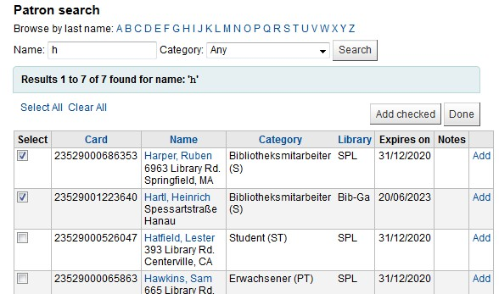
You are encouraged to shorten the list of patron names displayed by selecting the initial letter of the surname and and possibly a category. You may even specify a substring from within <firstname> <surname> to further narrow the list. Entering * for Name will display all the patrons. From the displayed list you can add selected patrons to the batch by pressing the Add button in a line. There is also an 'Add checked' button to add all the patrons that you chose bei selecting in the first column. After adding patrons from the displayed list you can start over, display another list and complement your batch. By pressing done you end your selection procedure.
And you return here:
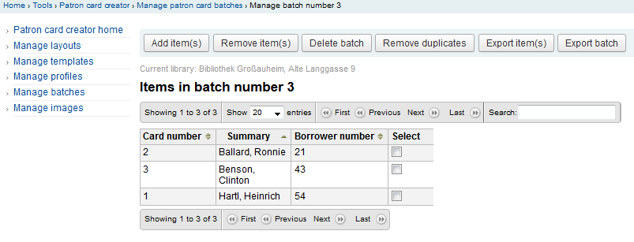
If you are satisfied with the chosen items in batch you should proceed to export. If you want to correct or even delete that batch you find the required function buttons to do so. You can always come back here through the menu item Manage batches.
Export is the final step producing a pdf you can download and print. If the prepared list of patron items comprises more items than you want to print now just select the ones you want to print now and press Export item(s). If you are happy to print all the patron cards listed then press Export batch
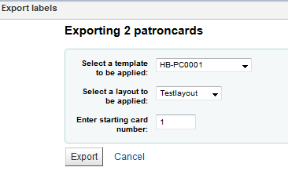
As you can see a few more informations are needed to prepare the pdf. First of all the patron cards are labels on a sheet that is described by a template. So the label sheet in the printer must be matched by choosing the appropriate template. And of curse you must decide on the a layout for each of the cards defined in a layout. And last not least your sheet with the labels in the printer may already have been used partially e.g. the first 6 labels may already have been used. In that situation we will want to start printing on label in position 7 on the sheet. The labels are numbered by rows from top to bottom. A final press on Export butten results in
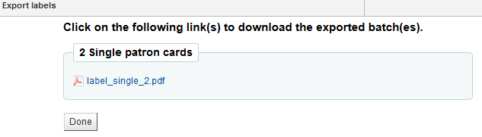
Now you have a chance to download and view and or print the generated patron cards.
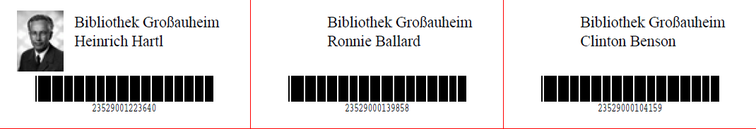
Above samples show a layout that comprises two textlines. The first one is just plain text, the second one is composed of <firstname> <surname> fields. A patron image is printed (if available) and the barcode of patrons number is displayed in code 39. All this is printed on a template with three columns and 8 rows using position 1-3 here. When printing this pdf please take care that your printer doesnt rescale the pdf (e.g do not fit to papersize) otherwise printing to the right position on the label sheet is spoiled.

1.6.5. Manage Images
- Get there: More > Tools > Patron Card Creator > Manage Images
Images uploaded using this tool will appear on the menu when creating patron card layouts. You are limited in how many images you can upload (not counting patron images) by the ImageLimit system preference.

Important
Images must be under 500k in size.

Note
Pictures uploaded with this tool should be at least 300dpi which is the minimum quality for a printable image.
In the center of the screen is a simple upload form, simply browse for the file on your computer and give it a name you'll recognize later.

Once the file is uploaded you will be presented with a confirmation message.

And the image will be listed with all of your others on the right hand side of the page.

To delete one or more of these images, click the checkbox to the right of each image you want to delete and click the 'Delete' button.

