Mana-kb usage documentation

Mana-kb is a global knowledge base for library-centric data.
It has been designed initially to interact with Koha, the Open Source ILS, but can be used by any other software.

This document describe Mana-kb feature and how to use them from Koha.

Table of contents
Activating Mana-kb 2
Get a token 3
Use Mana-KB for subscriptions 5
Consume data 5
Produce data 6
Use Mana-kb for SQL/reports 8
Consume data 8
Produce data 8
Q&A 10
What about my privacy ? 10
What about the license ? 10
What about data quality ? 10
April 2017, what does mana-kb contain ? 10
I’d like to submit a lot of data 10
Who’s who ? 10
What’s next 11

Activating Mana-kb
By default, Mana-kb is not activated. When you go to the admin page you get a warning message :
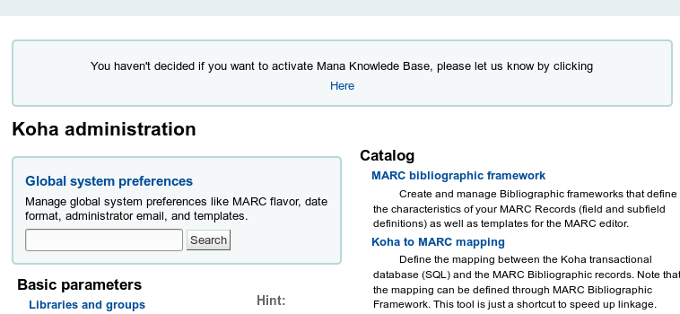
To get rid of this system preference, you can go to the Mana-kb syspref page :
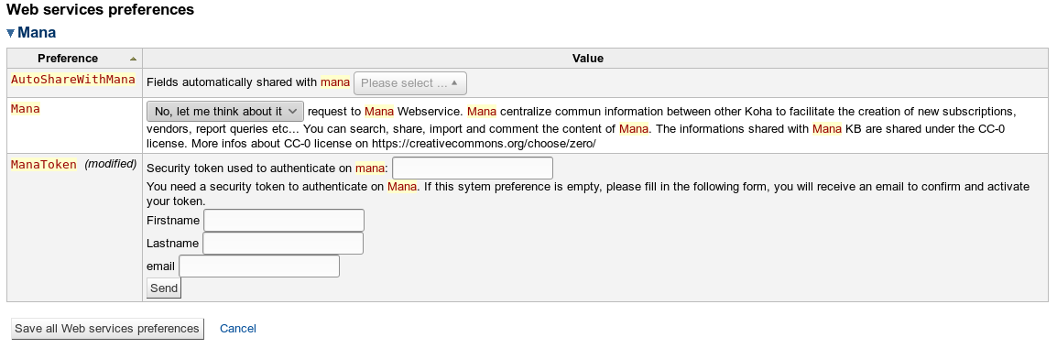
Chose « disable » if you don’t want to use Mana-kb
Chose « enable » if you want to use it

Get a token
Before using it, you need to create a token on the Mana-kb platform. This token is needed to avoid spamming/flooding : Mana-kb relies on webservices, that can provide data that will be added to the knowledge base. Without a token, anyone could flood Mana-kb with fake data. Also note that we keep track of all submitted data by storing the token. If someone creates a valid token, then flood us, it will be easy to revoke the token and then delete useless data.
In order to create a token, just fill the form with your name and email :
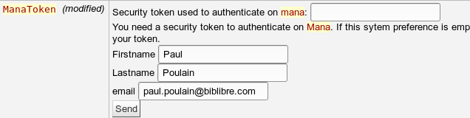
then hit « send »
The token is immediately generated and added :
IMPORTANT : the token is not active yet !
You’ll have to go to your mailbox, where you’ll find an email to validate it :
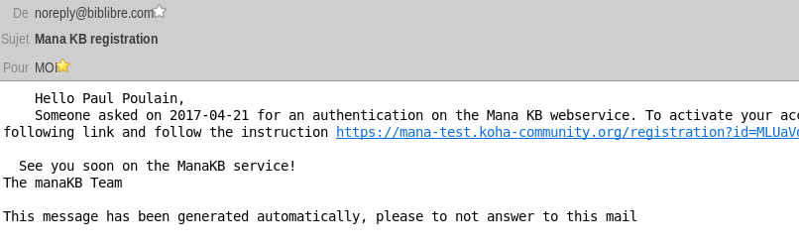
Click on the link, to reach a validation page :
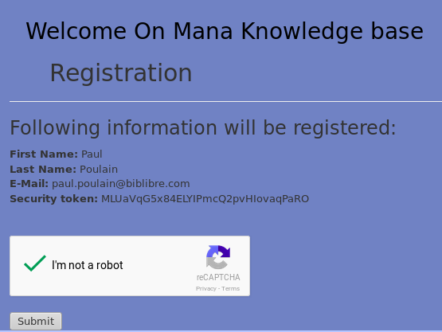
Validate the captcha, submit the form, and it’s done :
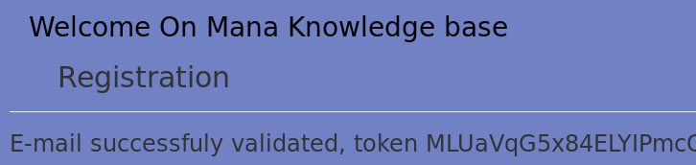
You can now use Mana-kb !

Use Mana-kb for subscriptions

Consume data
Mana-kb will help you filling quickly and efficiently your subscriptions.
Let’s got creating a new subscription. Start as usual :
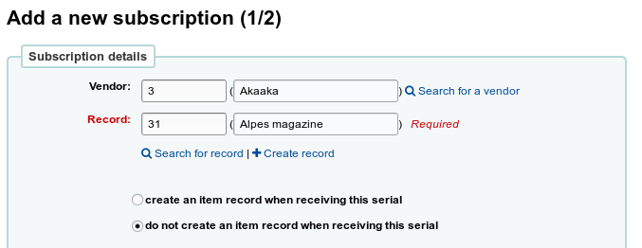
when you reach the second part of creating a subscription, Koha will query Mana-kb in the background. If someone already has shared a subscription for this serial, you’ll get a message :
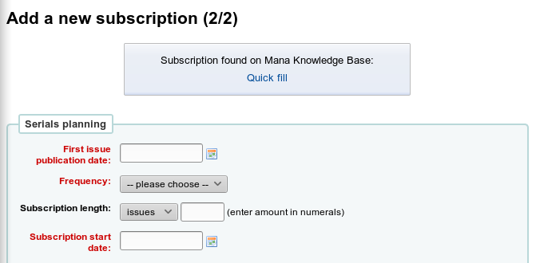
Click on « Quick fill », and Koha will propose the list of result that may correspond to your subscription.
Some important things here :
- Mana-kb relies on everyone’s submissions: more than one person can share the same subscription. Mana-kb includes a de-duplication mechanism, but, as there’s more than one way to express a numbering pattern, sometimes you’ll get more than one result for the same subscription.
- To help you choose, you’ll see additional informations :
The details of the subscription (title, publisher, ISSN, frequency, numbering pattern) (1)
  - How many people have used this entry (2)
  - When it was used for the last time (3)
  - Additional comments made by other librarians (4). You can report a mistake and/or add a comment by hitting the « Report mistake » button (5).
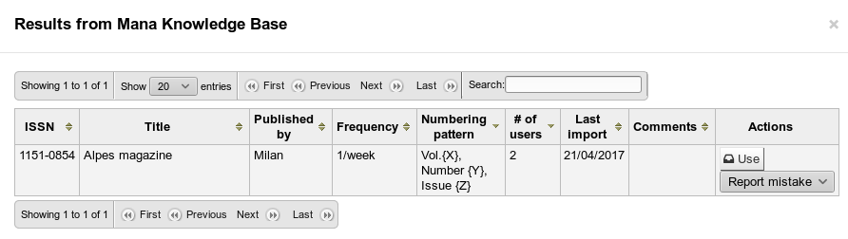
1
2
3
4
5
Note that only data in your staff interface language(s) are displayed.
If you find what you’re looking for, click on « use », and the data will be retrieved :
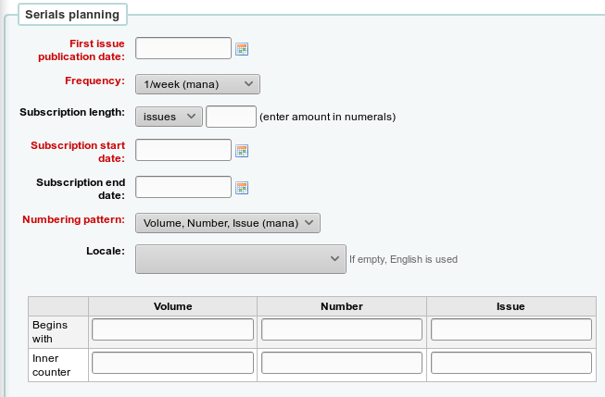
Enter your own data (first issue, subscription start, begin with, …)
and save the subscription.
It’s done ! You can now use your subscription like any other (receiving issues, claiming late issues, …)

Produce data
Mana-kb will become more and more efficient over time, but only if libraries share data. That’s why you’ll be able to share in a few clicks your own subscription description.
Let’s suppose you’ve added a subscription, and found nothing in the Mana-kb. Once you’ve saved the subscription, you’ll be able to share it with Mana-kb :
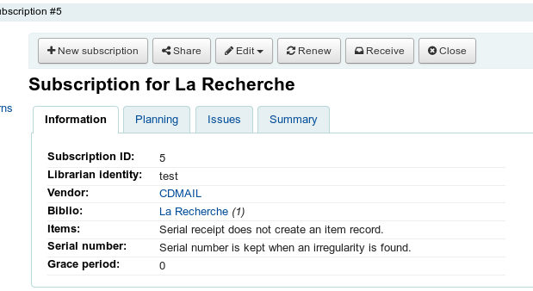
Hit the « share button », you’ll get a box to confirm.
If you have more than one language activated on the staff interface, you’ll have to chose the language of this shared data :
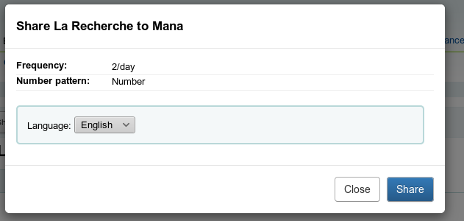
Once you’ve shared, you’ll be thanked by Mana-kb, it’s done ! (easy, isn’t it?)
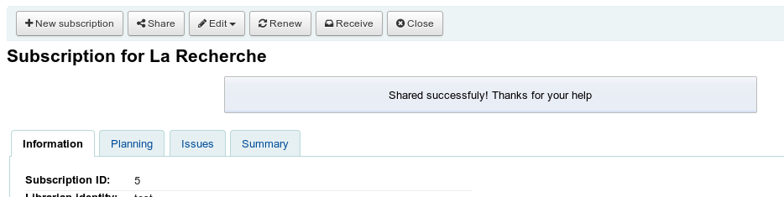

Use Mana-kb for SQL/reports

Consume data
When Mana-kb is activated, if you go to the reports module of Koha, you’ll find a box to query Mana-kb to quickly retrieve other’s reports :
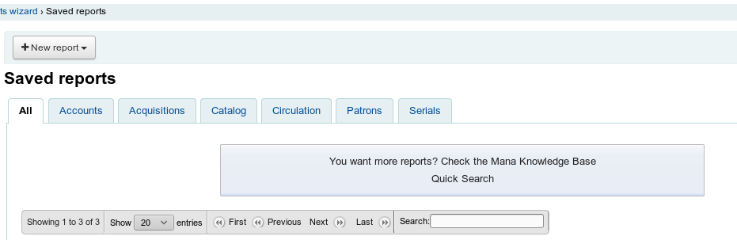
If the « quick search » link, you’ll get a search form :
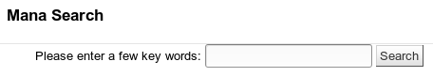
Enter what you’re looking for (« acquisition », « list of patrons », …)
if there are some reports that fit your question, they’ll be listed :
To help you choosing, you’ll see additional informations :
- the details of the report (name, notes, type). If you put your mouse on a note, you’ll see the detail of the SQL (1)
- how many people have used this entry (2)
- When it has been used for the last time (3)
- Additional comments made by other librarians (4). You can report a mistake and/or add a comment by hitting the « Report mistake » button (5).
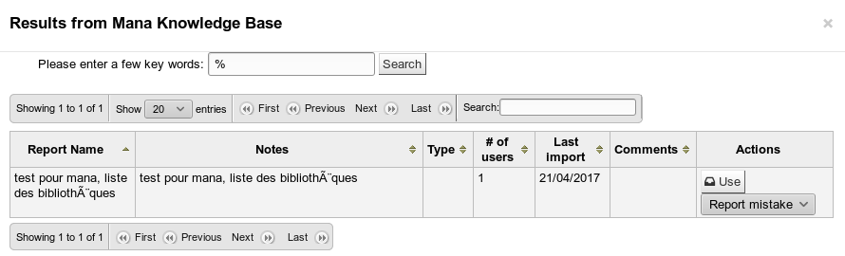
Just hit « use » to import this report in your local Koha. You can use it as any other report (and modify it if you need. That will not change the Mana-kb one, only your local one)
1
2
3
4
5

Produce data
As for subscriptions, Mana-kb will become more and more useful if you share your own reports !
In order to share, you just have to hit the « share » button in the list of saved report. Note Mana-kb requires the name AND the description to be more than 20 characters to accept the sharing. A good description will make your report more useful for others !

Q&A

What about my privacy ?
- We don’t store anything about you when you use/consume Mana-kb data
- We keep your token and name/firstname/email in our database
- Your token is associated with data you submit. Thus, you get the ownership of the data you submit. Keeping the token will also be helpful if someone tries to break, fill or overload Mana-KB with repeated and automated submissions.
in 2017, Mana-kb is hosted by BibLibre, in the name of the Koha community. We will never use your email, for any reason. We will never share with to anyone.

What about the license ?
The license of the database is CC BY-SA.
The license of the Mana-kb software (the webservices) is GPL v2.

What about data quality ?
You trust us to provide a high quality Koha ? We trust you to provide high quality data ! We’ve implemented the option to have any librarian able to report useless data.
In the near future, we will be able to nominate librarians who can delete data.
In the future, we can also make some change in our internal algorithm : for now, Mana-kb webservices returns every result found. We could limit to results used « recently » or without any problem reported,… We store all data, and plan to improve Mana-KB webservices according to feedback we get from librarie.

April 2017, what does mana-kb contain ?
We’re uploaded thousands of subscriptions, provided by French libraries (so most of them are French)
We’ve uploaded most of the reports available in the wiki page :https://wiki.koha-community.org/wiki/SQL_Reports_Library

I’d like to submit a lot of data
We’ve developed some tools to export your subscriptions in a CSV file. Ask us (paul.poulain@biblibre.com), and we will send it to you. Return the CSV to us, and we will include it to Mana-KB.

Who’s who ?
The Mana-KB project has been started by BibLibre, company dedicated to Open Source for libraries.
The Mana-KB server is provided and maintained by BibLibre as long as BibLibre and the Koha community think it’s the best option.

What’s next
Mana-KB has been designed to be easy to expand. We plan to add many data :
- other Koha related data (XSLT, MARC modification templates, frameworks, …)
- Other non-Koha related data
  - K-BART or ONIX-PL files, for electronic resources
  - “Patron who read this also read that” webservice (send an isbn, get reading suggestions)
Note that, due to the Open Source & CC nature of Mana-KB, any software can use and expand it.

