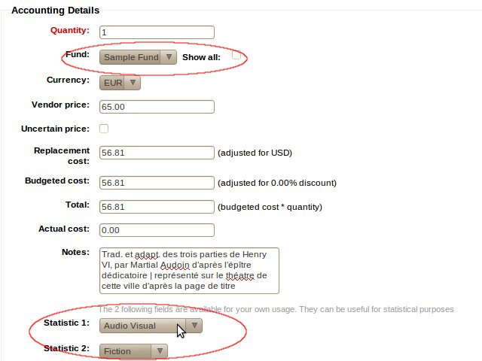
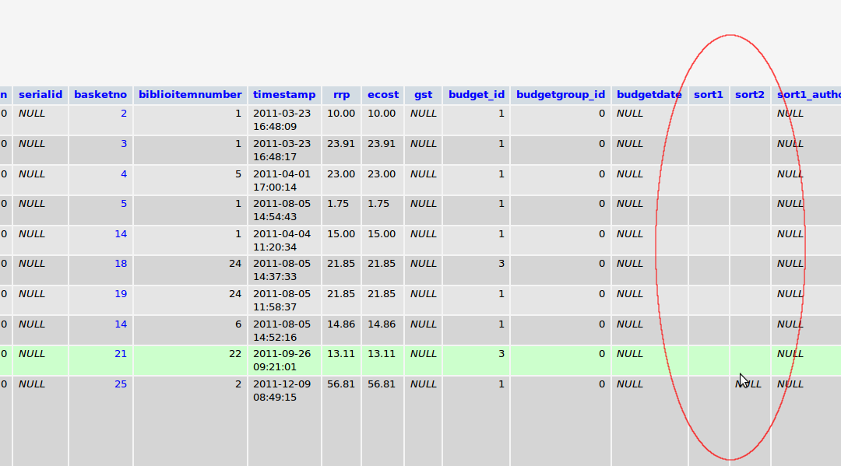
Creating a new order, select values for Statistic 1 and Statistic 2 and save:

Result in database (aqorder) :

aqorder.sort1 and aqorder.sort2 are empty.

