Bug 13327 – Screenshots from testing

When: OPACPopupAuthorsSearch – Enabled and OPACXSLTDetailsDisplay - Default
- The modal does not appear/work for subject terms.

Record display (for reference) – uses ‘old’ style search icons:

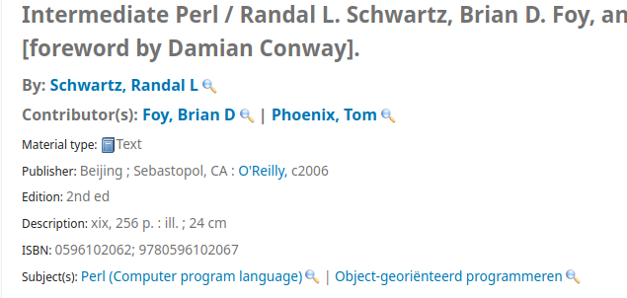
New style for modal (much nicer):

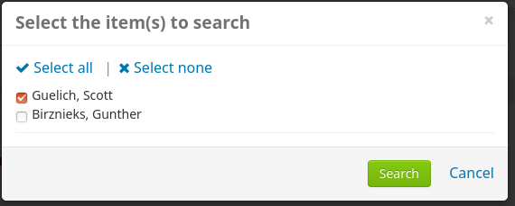

When: OPACPopupAuthorsSearch – Enabled and OPACXSLTDetailsDisplay - Empty

- search icon different for additional authors
- old search icon displays for ‘Subject(s):’
- the modal for subject terms works, but uses ‘old style’

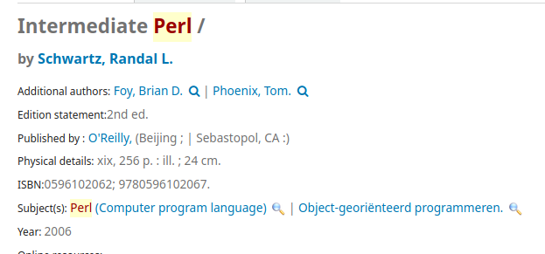


When: OPACPopupAuthorsSearch – Disabled and OPACXSLTDetailsDisplay - Empty

Record display the same as for Enabled + Empty:
- search icon different for additional authors
- old search icon displays for ‘Subject(s):’



