Bug 24159 Testing 24/3/20
- Test 1:
Config:
Loan periods define in Circulation Rules for Hourly and Books item types:
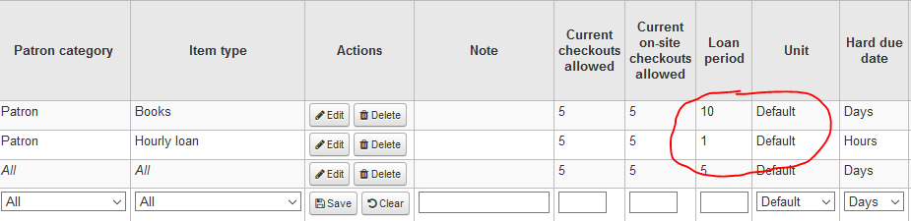

useDaysMode syspref setting:
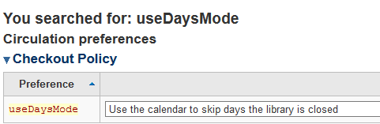

Circulation Calendar 24/3/20 set as closed for Centreville Library:
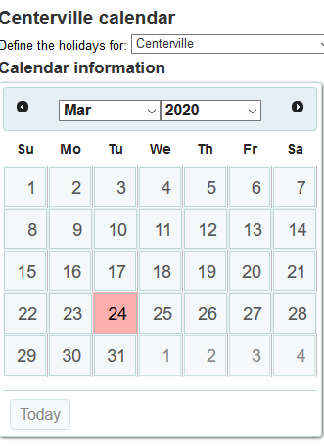

Checkouts to patron:

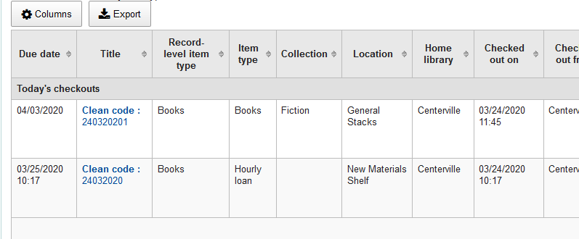
Due date/time for hourly loan is pushed to next day.

- Test 2
UseDaysMode syspref set to:
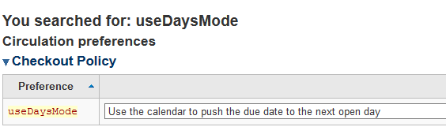

Checkout to borrower:

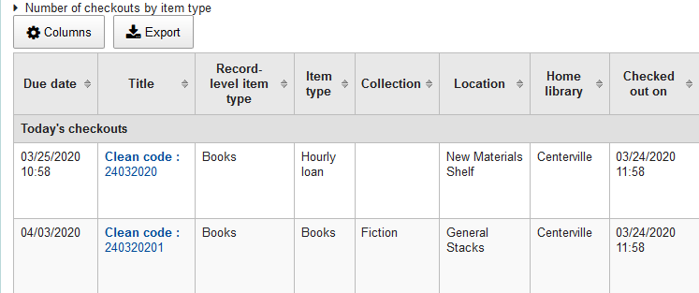
Due date/time for hourly loan is pushed to next day.
- Test 3
useDaysMode syspref setting:

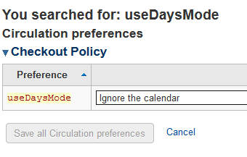

Checkout to patron:
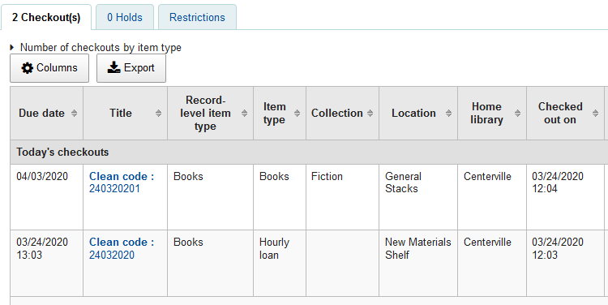
Due date/hour for hourly loan remains on date of checkout.

- Test 4
useDaysMode syspref setting:
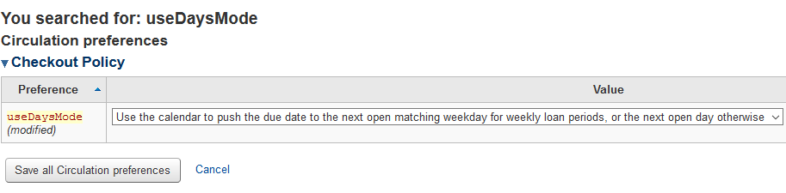

Checkout to patron:
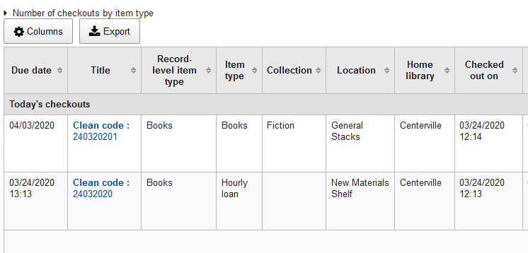
Due date/hour for hourly loan remains on date of checkout.

IT Carlow uses the useDaysMode set to Use the Calendar to Push the due date to next open day on our live system.

