Bug 24159 Testing 25/03/20

Config:
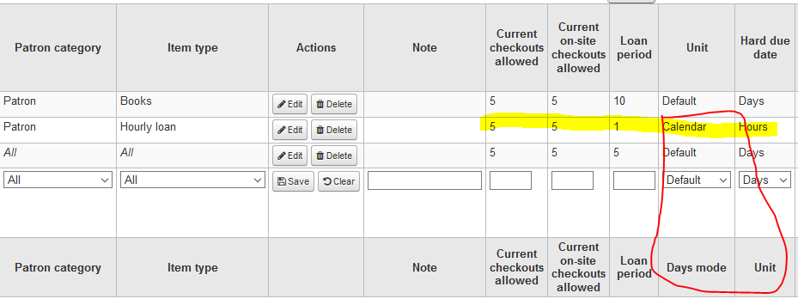
Days Mode set to ‘Calendar’ for hourly loan

useDaysMode:
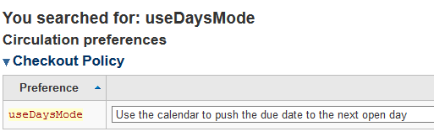
Circulation Calendar:
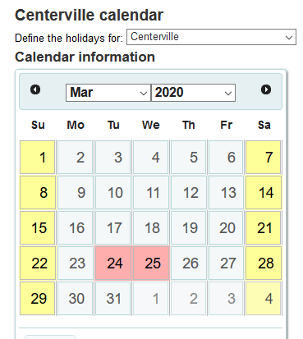
Replicates IT Carlow weekend library closed days
Test (1)
Checkout result:
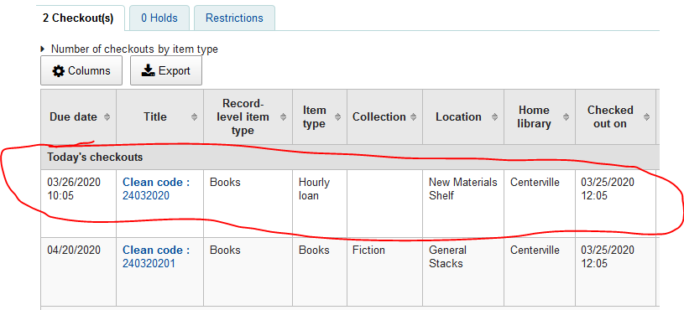
Due date for hourly loan moved onto next open day.

