Testing 27/3/20
Config:
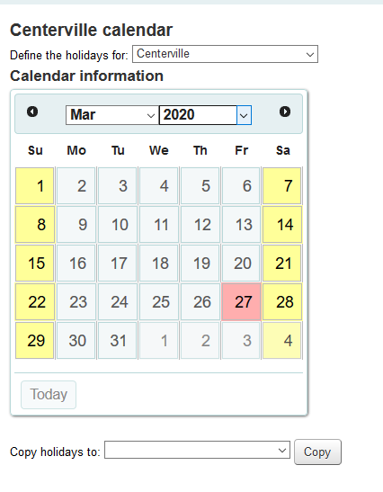
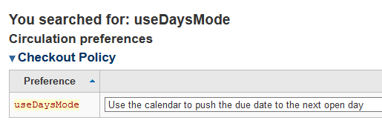
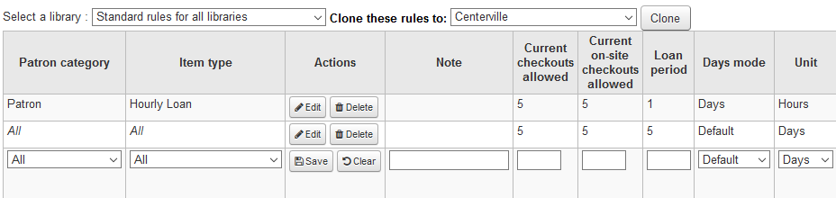

Hourly loan correctly checked out with due date on same day + 1 hr:
