Bug 24159 testing 3/4/20
Configuration 1.
Calendar closed day 3/4/20, 4/3/20, 5/3/20 (ITC weekend closed days)
useDaysMode syspref: Use the calendar to push due date to next open day.
Circulation Rules hourly loan Days Mode: Days (ignore calendar)

1 hour loan correctly checked out for same date:
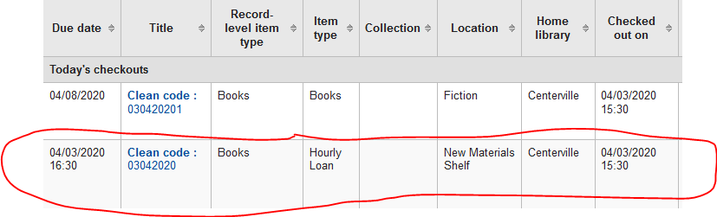

Configuration 2.
Calendar closed day 3/4/20, 4/3/20, 5/3/20 (ITC weekend closed days)
useDaysMode syspref: Use the calendar to skip the days the library is closed.
Circulation Rules hourly loan Days Mode: Days (ignore calendar)
1 hour loan correctly checked out for same due date: 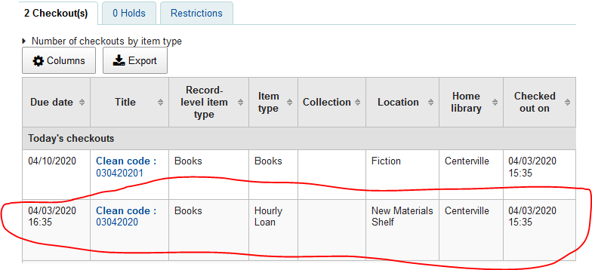

Configuration 3.
Calendar closed day 3/4/20, 4/3/20, 5/3/20 (ITC weekend closed days)
useDaysMode syspref: Ignore Calendar
Circulation Rules hourly loan Days Mode: Days (ignore calendar)
1 hour loan correctly checked out for same due date:
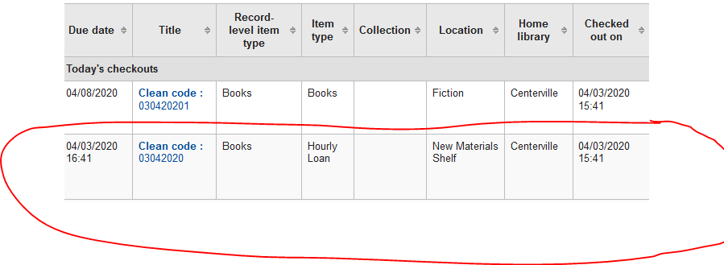

Configuration 4.
Calendar closed day 3/4/20, 4/3/20, 5/3/20 (ITC weekend closed days)
useDaysMode syspref: Use calendar to push due date to next open matching weekday for weekly loan periods or next open day otherwise
Circulation Rules hourly loan Days Mode: Days (ignore calendar)
1 hour loan correctly checked out for same due date:
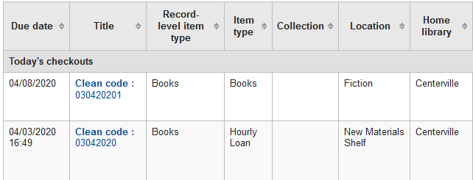

Configuration 5.
Calendar closed day 3/4/20, 4/3/20, 5/3/20 (ITC weekend closed days)
useDaysMode syspref: Use the calendar to push due date to next open day.
Circulation Rules hourly loan Days Mode: Default
Houly loan is correctly pushed to next open day
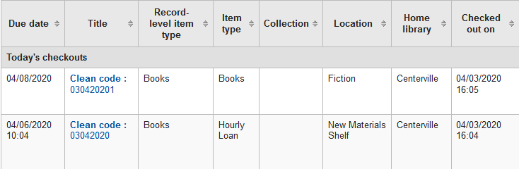

Configuration 6.
Calendar closed day 3/4/20, 4/3/20, 5/3/20 (ITC weekend closed days)
useDaysMode syspref: Use the calendar to push due date to next open day.
Circulation Rules hourly loan Days Mode: Calendar (skip days library is closed)
Houly loan is correctly pushed to next open day
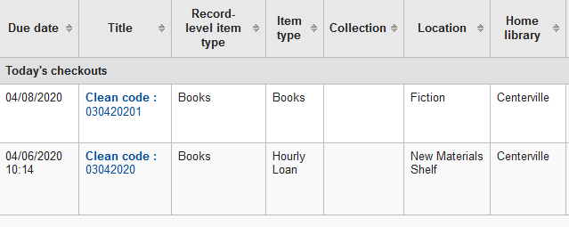

Configuration 7.
Calendar closed day 3/4/20, 4/3/20, 5/3/20 (ITC weekend closed days)
useDaysMode syspref: Use the calendar to push due date to next open day.
Circulation Rules hourly loan Days Mode: Datedue (push due date to next open day)
Houly loan is correctly pushed to next open day
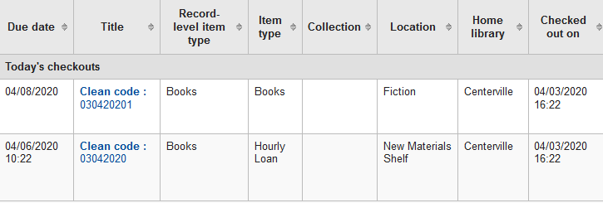

Configuration 8. (tested 8/4/20)
Calendar closed day 8/4/20, 11/3/20, 12/3/20 (ITC weekend closed days)
useDaysMode syspref: Use the calendar to push due date to next open day.
Circulation Rules hourly loan Days Mode: DaysWeek (Use the calendar to push the due date to the next open matching weekday for weekly loan periods, or the next open day otherwise)
Houly loan is correctly pushed to next open day

