The page might look something like this:
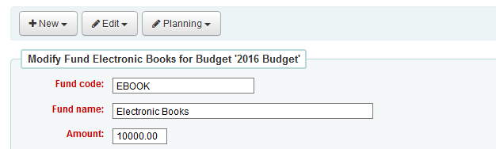
Fund Amount: $10,500.00
Modify Fund Amount:
Add
Subtract
Transfer to
Active funds
Modify Amount:
Reason:
Modify
This would display the history of changes to a budget. The page would load with the history collapsed.
Date (Take system date or input date?) | Increase/Decrease | Fund Amount | Reason for change
12/19/2019 | $500.00 (+) | 10,500.00 | Donation for Digital collection
10/01/2019 |  | 10,000.00 | Initial Budget
History:
