Confusing “checkin date”
This checkin date is the date that the item went from long overdue to lost.
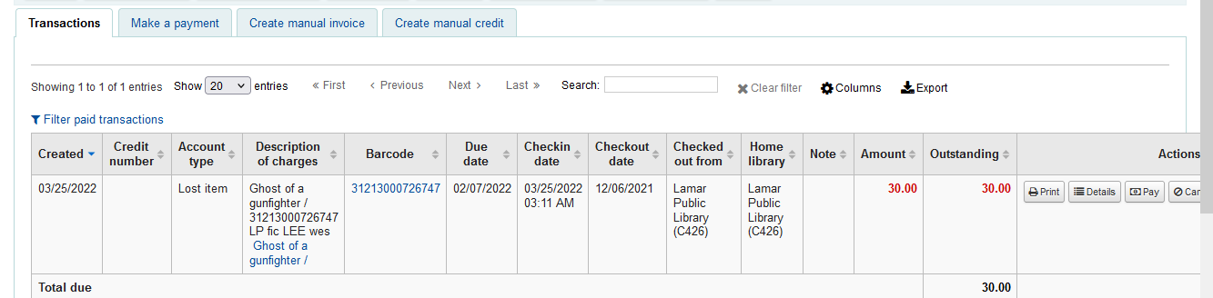
Maybe column heading should be “Checkin or Status Change date”, and then under date maybe in red – change from longoverdue to lost
Long overdue to lost
Checkin or Status change date
Also under circulation history the date showing as return date is the date it went lost. Also confusing.
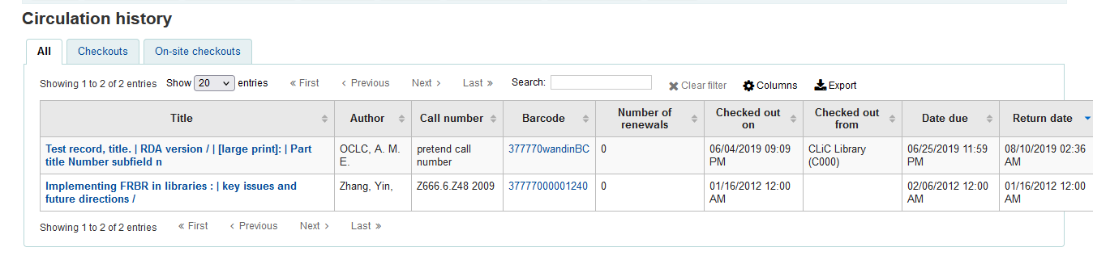
Perhaps the same column heading and additional information could be used here as well
Date lost
Returned or status change date
R st status changed date

