Constraints: (1) We are a library that cannot roll funds from one year to the next so it is spend it or lose it. (2) Anything we purchase in a given year must be received in that year. (3) Our fiscal year goes from Oct 1 to Sept 30. The end of September and October are big publishing times getting ready for the Holliday Season.
Problem: When the end of the year draws close, we have two conflicting needs. We want to spend all the money we have for collections, and we want to order ahead to make sure our customers can see the exciting new titles we will be getting and that we have ordered the next book by their favorite author. Currently there is not a clean and clear way to both order the titles coming out in the next fiscal year and have an accurate account of what we have spent this fiscal year.
Things I have thought about: Create the next year’s budget ahead of time with matching fund codes so we can close out the year and have any on order items move to the next year. Then add baskets with content for next year to next year’s budget. This becomes a problem with EDI ordering because we have the same fund codes for both years and when the items are received, there is no way for EDI to know which year’s fund code to charge the item to.
Create the next year’s budget ahead of time with unique fund codes. Then add baskets with content for next year to next year’s budget. This is a problem because when closing the current budget, the on order items will not roll to the next year because the fund codes don’t match. Also, with EDI ordering we would have to have two fund codes to properly assign the items to the right year. (Ex. We would need two fund codes for Adult Fiction, one for the current year and one for next year. When we would have to apply the grid with the correct fund code.)
The Ideal solution would be to have something like this:
Create the next year’s budget ahead of time and have it active. Now there would be two active budgets. This will allow fund codes for both years to display when creating baskets and ordering. The Fund name can distinguish the funds for each year. It would look something like this.
The Budget ID = 6
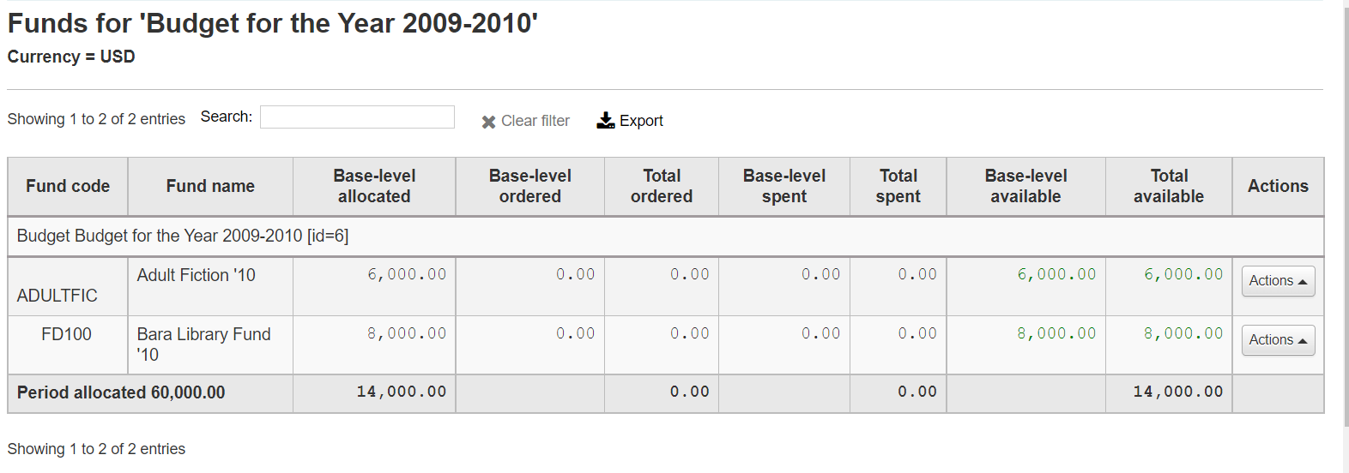

Budget ID = 7
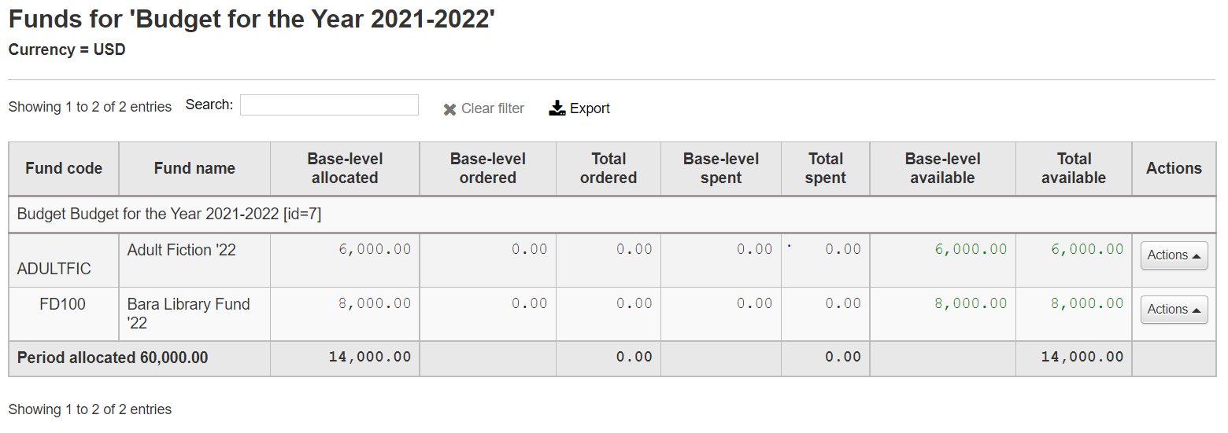
For the case where items are put in a basket one at a time (from an existing record, new record….) When a basket is created,
we can pick the fund and the appropriate fund will be obvious. This is for Non-EDI.
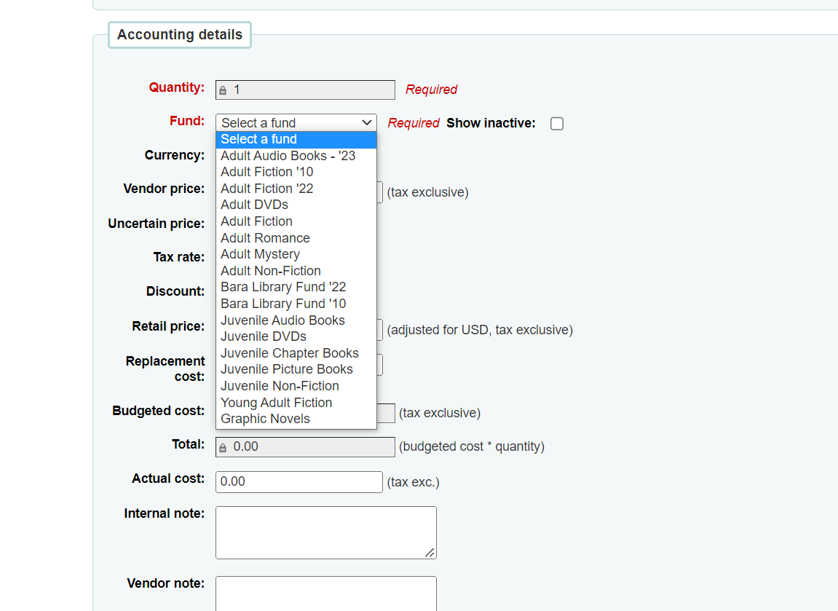

When the items are received, the correct budget/fund will be updated.
For Non-EDI case where files are downloaded from vendors. The list of items is created on the vendor site and ordered there. The list is downloaded and added to a basket in Koha and the items are visible to patrons. If grids are used, the fund codes be added on the vendor site with the grid. When added to the Koha basket, the fund codes will need to be updated to get the correct budget.
NEW FUNCTION: For both Non-EDI ordering where files are uploaded from the vendor and for EDI ordering, to make updating the fund code more efficient, add the function to select items with checkboxes and then allow a batch update of the fund code. The checkboxes are already there.
In the case below we would want to update the funds to the ’22 fund rather than the ’10 fund.
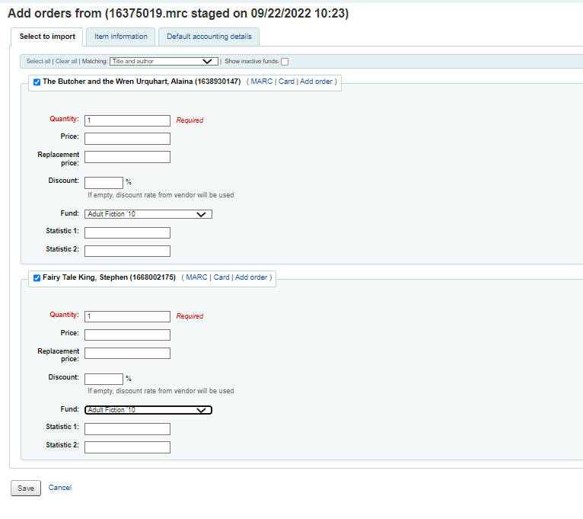
For EDI processing: At this point after the Fund is updated to Adult Fiction ’22, Koha will know that the budget ID is 7. Ideally, Koha would pass the budget ID of 7 in the EDI information. That way when the Item information is passed back to us when Koha receives the items, Koha can look at the budget ID and know that the cost needs to be moved from the ordered column of budget 7 to the spent column of the budget 7.
I have tested closing the budget 6 and rolling over the ordered items to budget 7 and if the budget 7 has something in the ordered column, the roll over will add what is in budget 6 to the stuff coming in from budget 7.

