After discussion at the koha-US Acquisitions SIG, we came up with the following functional change for non-EDI receiving.
Current receiving page (for reference):
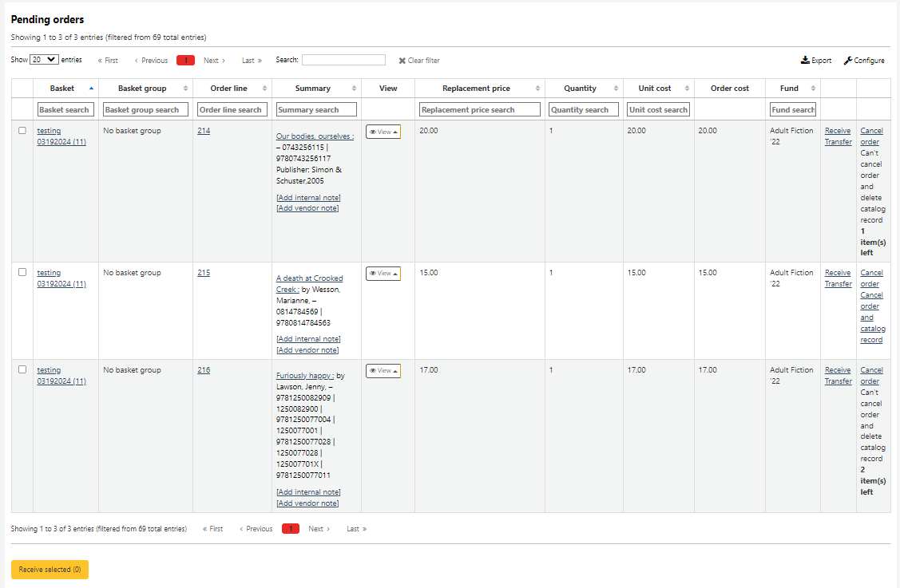
This page displays the significant information for each item to be received: Replacement price, Quantity, Unit cost, and Fund. What would really decrease the time spent on receiving would be to have the ability to complete the receiving process from this page. The workflow would go like this.
For items where the information is correct: The staff person would verify the prices, quantity, and fund from this page and if everything is correct, check the check box. Once all the items for the invoice are verified and checked, the yellow ‘Receive selected (X)’ button would actually receive the items. And the items would be moved to the Already received part of the page.
For items where the information needs to be changed: We have three options in order of preference.
Option 1: This option transforms the cells in the Replacement price, Quantity, Unit cost and Fund columns to editable cells. If a cell for an item had incorrect information, the acquisitions person would click on the cell and then edit the contents. For the Fund column, the cell when clicked on would have a dropdown of the active funds. For the price columns, the number in the column would be editable. For the quantity column, if there were multiple items ordered but not all items arrived at the library to be received, the quantity column would have a field to enter the items to be received.
Option 2: This option would add another button at the bottom of the Pending Orders next to the ‘Receive selected’ that would say ‘Modify and Receive selected’. For each item that is selected when the ‘Modify and Receive selected’ button is selected, Koha would behave like it currently does opening the receive window for each selected item to allow modifications. The workflow would be to first select all the items that are correct and click the ‘Receive selected’ button. Next select all the items that need to be modified and click the ‘Modify and Receive selected’ button and individually modify and receive the items.
Option 3: This option would add an ‘Edit’ option to the column with Receive and Transfer. When the Edit option is selected, the current receive window would open and the values could be edited and then saved. As I am writing this up and thinking about this some more, I am not sure this option really has value. If you have this window open, you might as well just receive the item.
