Does removal of the ‘success content’ in the
AUTO_RENEWAL_DGST cause the ‘too_many’
Notice to be prepared (contrary to Bug 34924)?
Yes.
As we moved towards upgrading to 23.11 I was asked to prevent items that auto-renewed without errors from appearing on the AUTO_RENEWALS_DGST in an attempt to reduce what my colleagues described as ‘pointless emails’.
We offer 9 auto-renewals on a one week loan item and with the new auto_renewal_final error we wanted the email sequence to move from:
1 checkout notice,
8 renewal notifications via the digest,
then 1 final renewal notification via the digest
to
1 checkout notice and
1 final renewal notifications via the digest.
I removed the ‘success content’ part of the template toolkit code and in testing on our upgrade server this appeared to work perfectly and my colleagues were delighted.
We were also delighted to see that the email sequence was:
1 checkout notice,
1 final renewal notifications via the digest and (contrary to 34924),
a digest mentioning the item when it failed renewal later.
(In 22.11 we are using the digest as a first notification that an item is overdue, so we were delighted we could continue with our existing workflow in 23.11).
However extended testing showed that the change to remove the success content concealed a nasty problem.
The change appears to work perfectly where there are no problems on the account. The reader does not receive the 8 ‘pointless emails’ (using my colleagues’ description). But where (say) a reader has a reserved item they are refusing to bring back, and they have other items on their account that are renewing routinely, an AUTO_RENEWALS_DGST is prepared every day an item renews (without error).
Yes, no mention is made of the item that renewed, but if a reader were to take a one-week loan out every day, and they were refusing to return another 1 week loan item that was reserved, they would receive a digest email demanding the return of the reserved item every day.
My testing has also confirmed that the removal of the success content was also triggering the notice for the too_many error later when the item failed to renew.
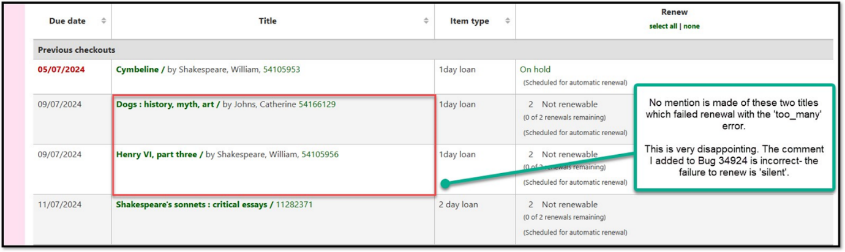
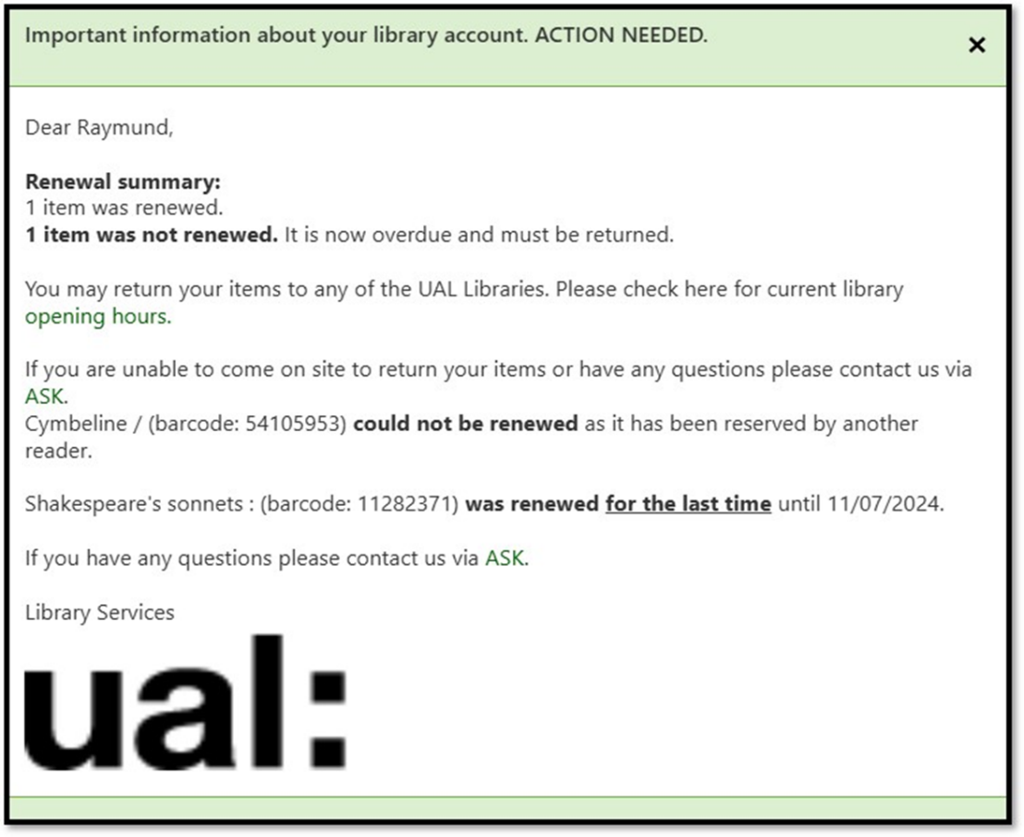
The removal of the success content part of the TT code in the digest is not a solution (unfortunately) and we have reverted to the default digest.
But the ability to optionally prevent error-less renewal notifications on the digest, and further to optionally have a digest prepared as well for the too_many error is functionality we would very much welcome.
Here is the full text of my (broken!) AUTO_RENEWALS_DGST notice, with the success content removed.
Subject line:
[% USE Koha %][% IF error %]Important information about your library account. ACTION NEEDED.[% END %]
Content:
[% IF error %]
Dear [% borrower.firstname %],<br/><br/><b>
[% IF error AND error ==1 %] [% error %] item listed below needs your attention. [% ELSIF error AND error >1 %][% error %] items listed below need your attention.[% END %]<br/><br/></b>
[% FOREACH checkout IN checkouts %]
[% IF checkout.auto_renew_error == 'too_many' %] [% checkout.item.biblio.title %] (barcode: [% checkout.item.barcode %]) <b>could not be renewed</b> as it has reached the maximum number of automatic renewals.<br/></br>
[% ELSIF checkout.auto_renew_error == 'on_reserve' %][% checkout.item.biblio.title %] (barcode: [% checkout.item.barcode %]) <b>could not be renewed</b> as it has been reserved by another reader.<br/><br/>
[% ELSIF checkout.auto_renew_error == 'restriction' %][% checkout.item.biblio.title %] (barcode: [% checkout.item.barcode %]) <b>could not be renewed</b> because your account has been restricted. <br/><br/>
[% ELSIF checkout.auto_renew_error == 'overdue' %][% checkout.item.biblio.title %] (barcode: [% checkout.item.barcode %]) <b>could not be renewed</b> because you have overdue items. <br/><br/>
[% ELSIF checkout.auto_renew_error == 'auto_too_late' %] [% checkout.item.biblio.title %] (barcode: [% checkout.item.barcode %]) <b>could not be renewed</b> as it is now too late for this item to be renewed automatically.<br/><br/>
[% ELSIF checkout.auto_renew_error == 'auto_too_much_oweing' %][% checkout.item.biblio.title %] (barcode: [% checkout.item.barcode %]) <b>could not be renewed</b> as your total unpaid fines and replacement fees for lost items are too high.<br/><br/>
[% ELSIF checkout.auto_renew_error == 'too_unseen' %][% checkout.item.biblio.title %] (barcode: [% checkout.item.barcode %]) <b>could not be renewed</b> as this item must be renewed in the library.<br/><br/>
[% ELSIF checkout.auto_renew_error == 'auto_renew_final' %][% checkout.item.biblio.title %] (barcode: [% checkout.item.barcode %]) <b>was renewed <u>for the last time</u> </b>until [% checkout.date_due | $KohaDates as_due_date => 1%]. <br/><br/>
[% ELSIF checkout.auto_renew_error == 'auto_unseen_final' %][% checkout.item.biblio.title %] (barcode: [% checkout.item.barcode %]) <b>was renewed for the last time </b>until [% checkout.date_due | $KohaDates as_due_date => 1%]<br/><br/>
[% ELSIF checkout.auto_renew_error == 'auto_account_expired' %][% checkout.item.biblio.title %] (barcode: [% checkout.item.barcode %]) <b>could not be renewed</b> as your account has expired.<br/>
[% END %][% END %]
Items that have renewed <u><b>for the last time </u></b>have reached their maximum renewals. They must be returned to the library but they can be reissued to you. <br/><br/>
You may return items to any of the UAL Libraries. Please check here for current library <a href=https://www.arts.ac.uk/students/library-services/library-service-hours>opening hours.</a><br/><br/>
If you have any questions please contact us via <a href=https://arts.ac.libanswers.com>ASK</a>.<br/><br/>
Library Services<br/>
<img height="86" src=https://acm.arts.ac.uk/nidp/images/ual-logo.png width="212">
[% END %]

