Bug 35656 - Autorenewal notices can resend content that has already been relayed to the patron
This repetition continues when items go overdue. And depending on how the readers borrow items, the repetition can be quite… extreme. (But some colleagues in the libraries like it!)
I issued myself items to be due on sequential days and placed a reservation on them all, and refused to return any of them. On the 29th I was told two items had failed to renew. But as the days went by each of the AUTO_RENEWALS_DGST emails I received contained information I have previously received.
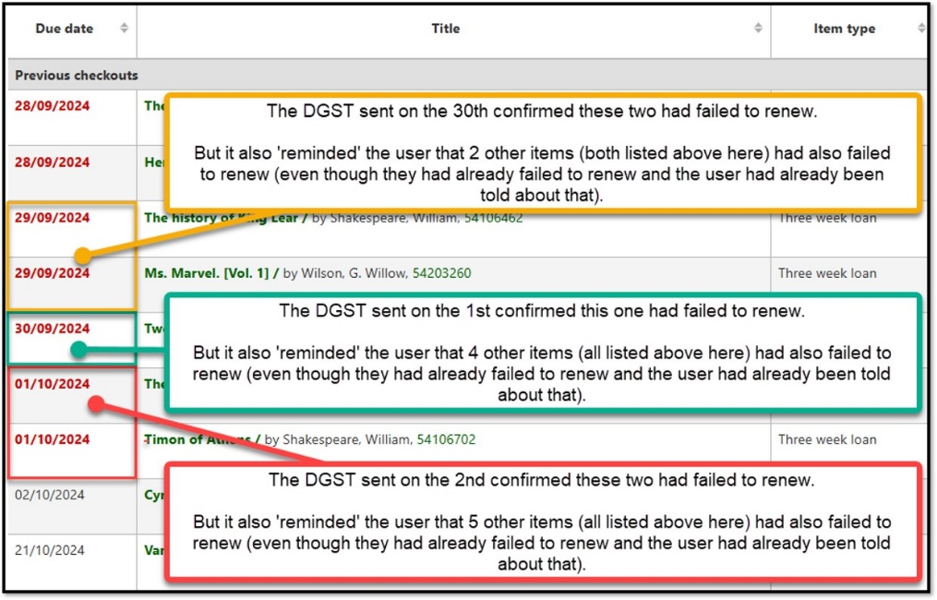
Here is the email for the ‘orange situation’ shown above:
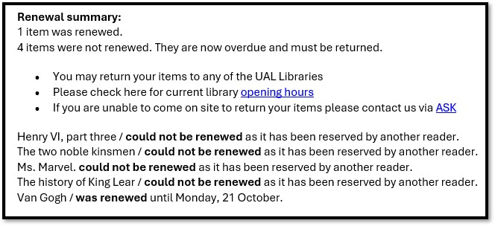
And here is the email for the ‘green’ situation’ shown above:
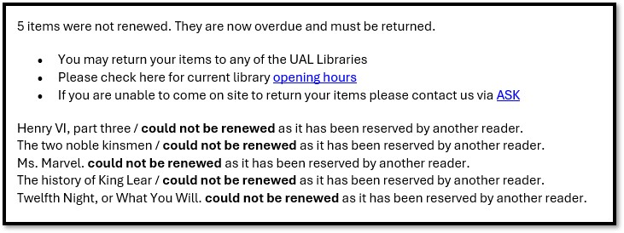
And here is the email for the ‘red situation’ shown above:
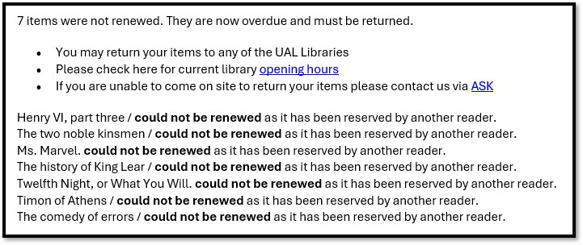
And on the 3rd, the AUTO_RENEWALS_DGST listed 8 items as having failed to renew (despite the fact that only one item was scheduled to renew).
The repetition problem continues when items go overdue.
We are using the AUTO_RENEWALS_DGST as in effect the first notification to readers that items have gone overdue. We send the first formal overdue notice (ODUE) after the item is 7 days late, and we apply a restriction on the account at the same time.
On the 7th, one of the items on hold (Twelfth night) which I am refusing to return went 7 days overdue and I was sent the ODUE notice:
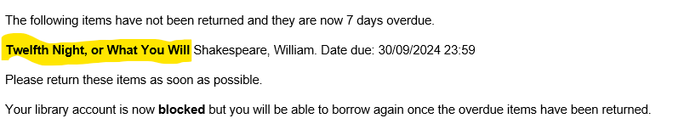
But a few days later another item on my account routinely renewed, and a digest was prepared alerting me to the new due date for the Van Gogh title. But I was reminded (for I think the 5th time) that the Twelfth night title had failed to renew.
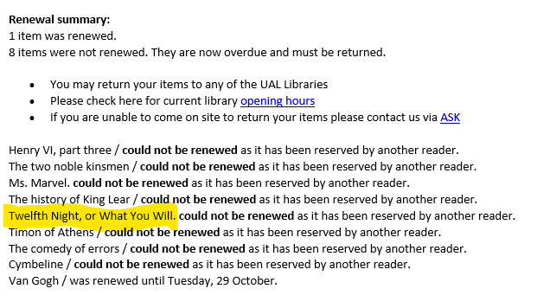
We sure are being diligent in reminding readers about items that have not renewed.

