Two bibilos was returned in the barcode search:
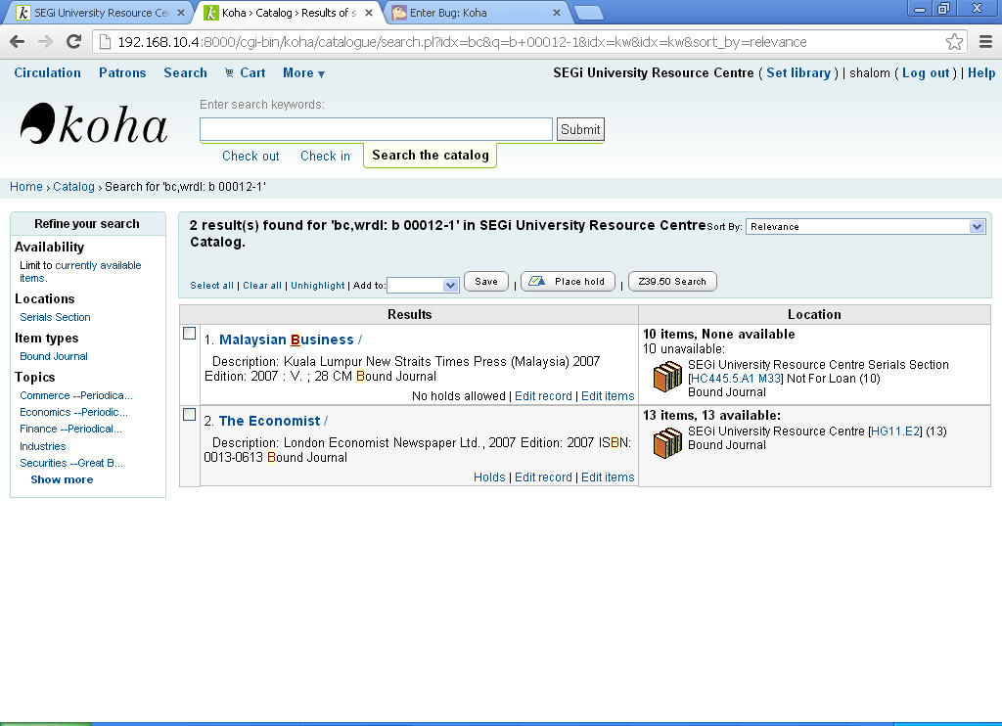
10 items attached to the first biblio, according to the search result, but in the bib detail page shown only four items
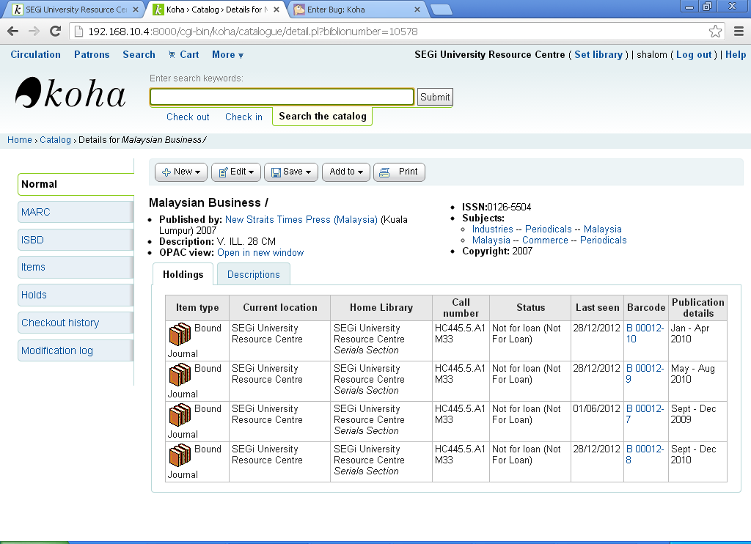

The barcode was initially belongs to a item in a deleted record (the second title in the search result) and later was attached to the first title.
When I click that second title in the search result page, I was redirected to the unknown record page (below):
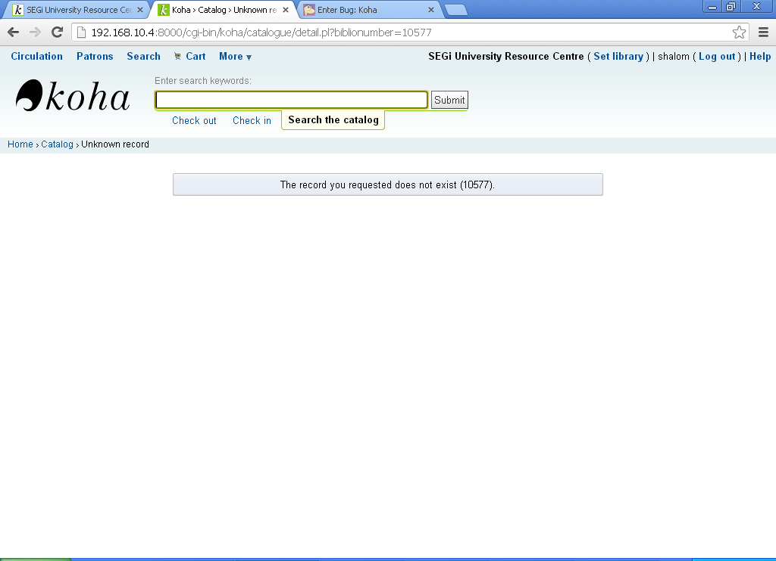
If I click “edit record” under the second title in the search result page, I got this error massage.
