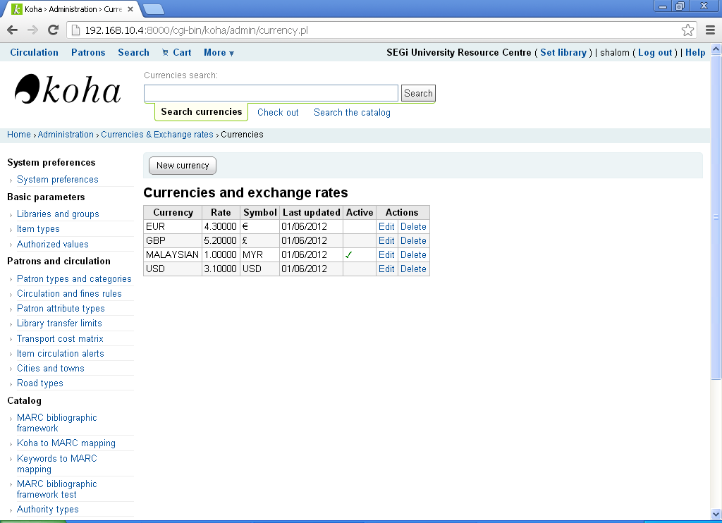
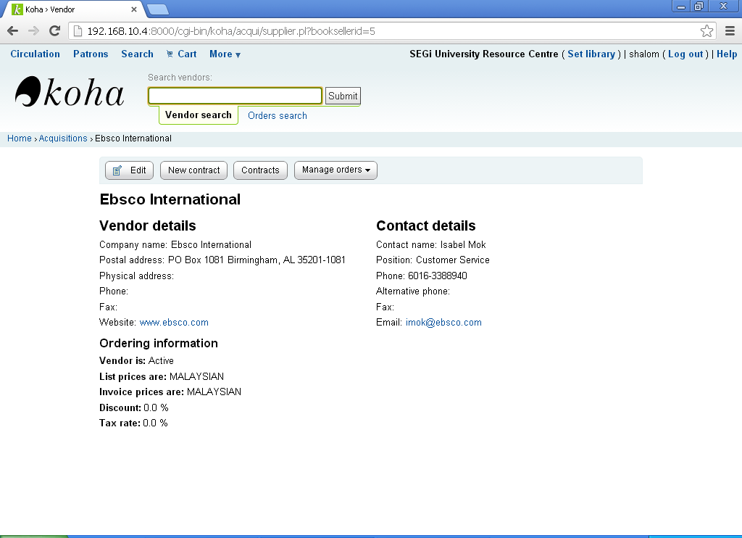
The active currency and vendor default currency is MALAYSIAN (above), basket also display MALAYSIAN in total amount (below).
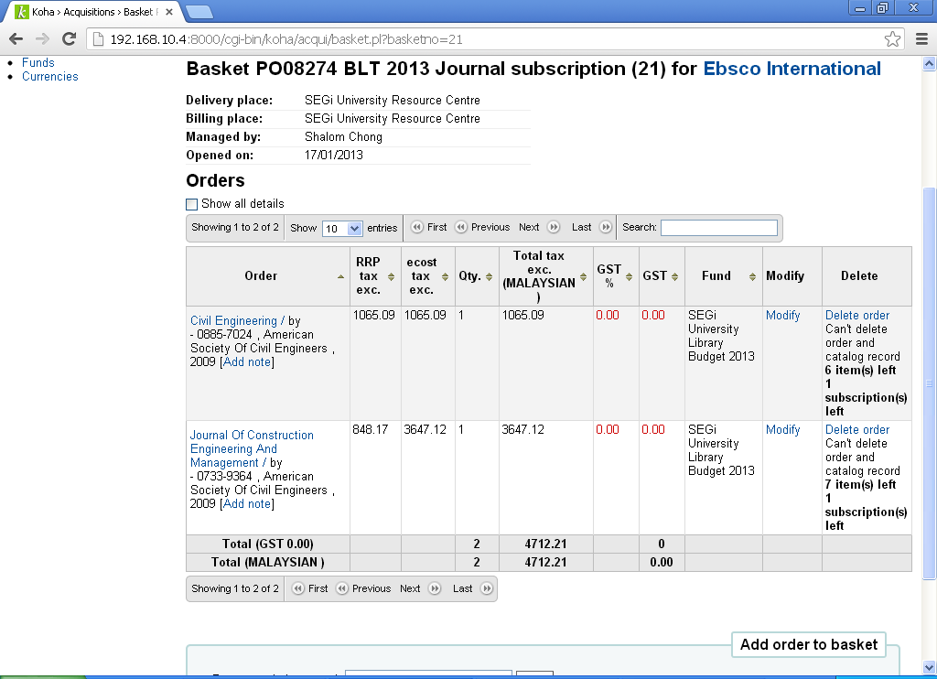
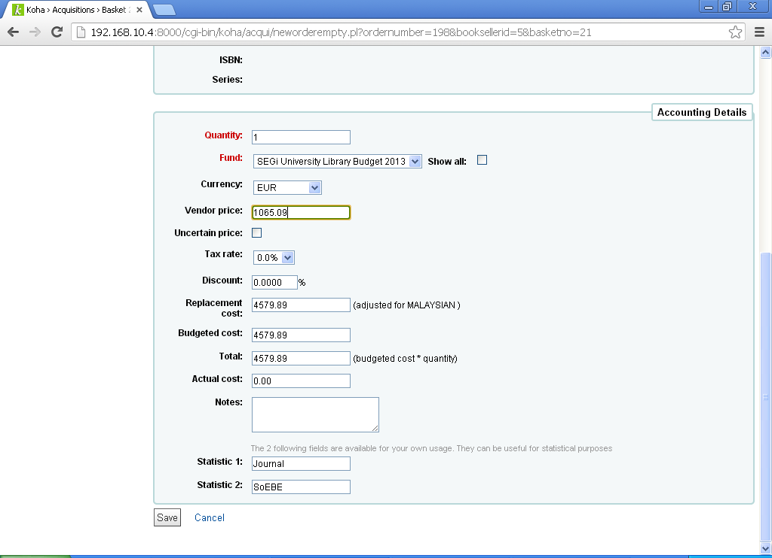
When modify order, currency was EUR as defult.
When change currency to MALAYSIAN, replacement cost, budgeted cost and Total will become NaN (below)
