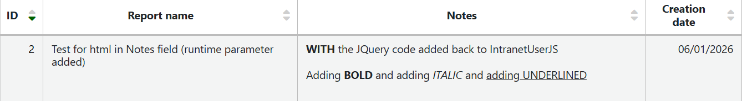

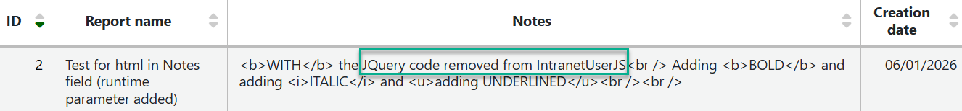

https://wiki.koha-community.org/wiki/JQuery_Library#Render_patron_messages_as_HTML_and_in_Report_notes

//BEGIN Creates to html function
$.fn.toHtml=function(){
return $(this).html($(this).text());
};
//BEGIN Changes messages back to HTML
$('#messages .circ-hlt').each(function() {
$(this).toHtml();
});
//BEGIN renders notes on reports in HTML $("#rep_guided_reports_start .label:contains('Notes:')").parent().wrap("<div id='reportnotes'></div>");
$('#table_reports tr td:nth-child(7), #reportnotes').each(function() {
$(this).toHtml();
});

