When highlighting subfields with a double click, don’t bring the subfield code:
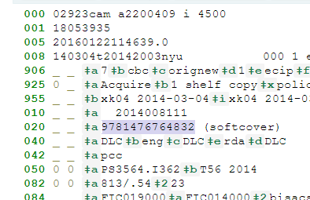
This selects a9781476764832 not “9781476764832” as it appears to be.

