In advanced search, error is given for “Unsupported Use attribute” when searching on title + author
In the advanced cataloging interface, searching LOC and the Seattle Public Library for author “Feeney” and title “Sometimes I Lie” results in a record from LOC and “Unsupported Use attribute” for SPL.
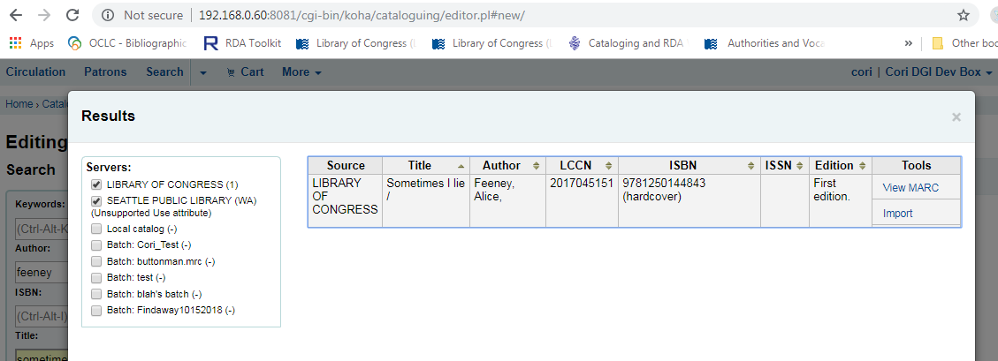
Figure 1
However, the same search using the button “New from Z39.50/SRU” from the basic cataloging interface results in records from LOC and SPL:
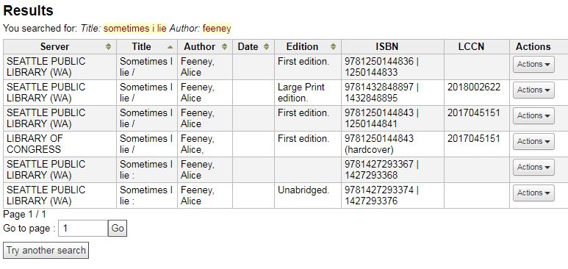
Figure 2

