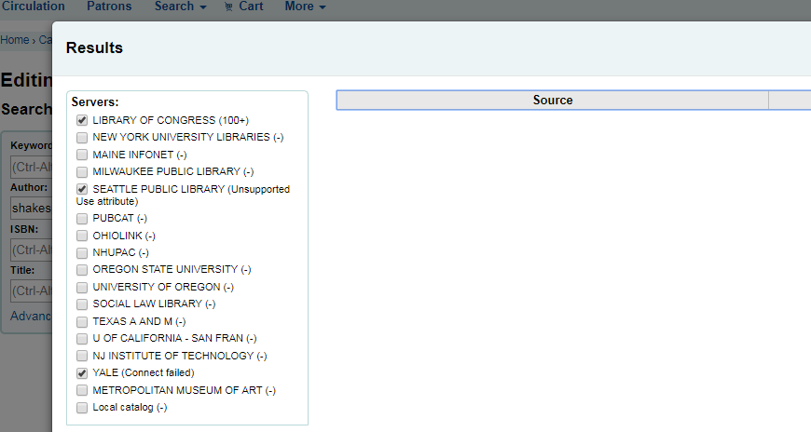

In the advanced cataloging editor, search for author “Shakespeare” and sort by "ISBN”. Results are lost after multiple “Next” buttons are pushed.

