Correct transaction in Koha 3.22.05 version

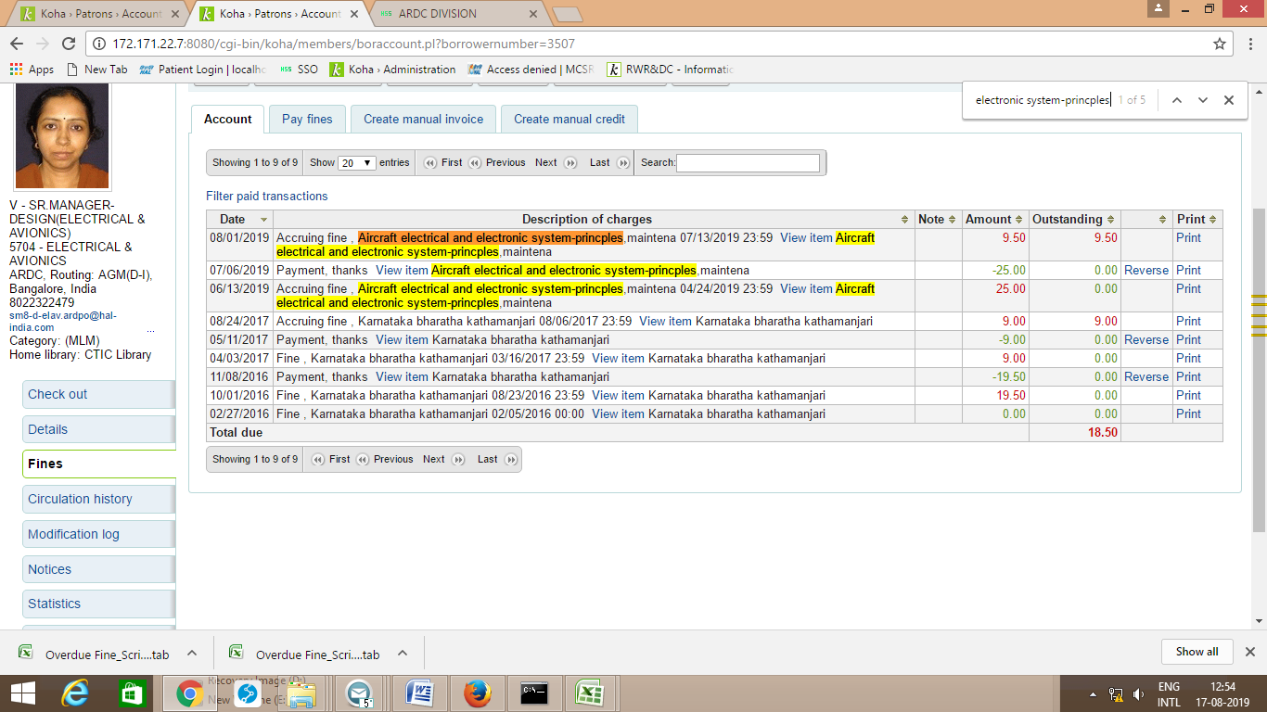
This transaction is getting deleted in Koha 18.11 during renewal

Error transaction in koha in Koha 18.11 version
